Research Using Online Databases
& Cobb Digital Library

Step 1: Log-on to the Cobb Digital Library

When accessing the Cobb Digital Library at home using https://cobb.mackinvia.com, use your Office 365 login (typically firstname.lastname and computer password).

Step 2: Access the Database
On the left-hand menu bar, select DATABASES. Then, navigate to the OPPOSING VIEWPOINTS database (you may have to click the green “load more” bar).

Step 3: Navigate through Topics
This database presents trending topics with arguments on both sides of the debate. Today, you will be looking at topics concerning how long school should last. To begin, you will need to scroll past ISSUES OF INTEREST and select BROWSE ALL ISSUES 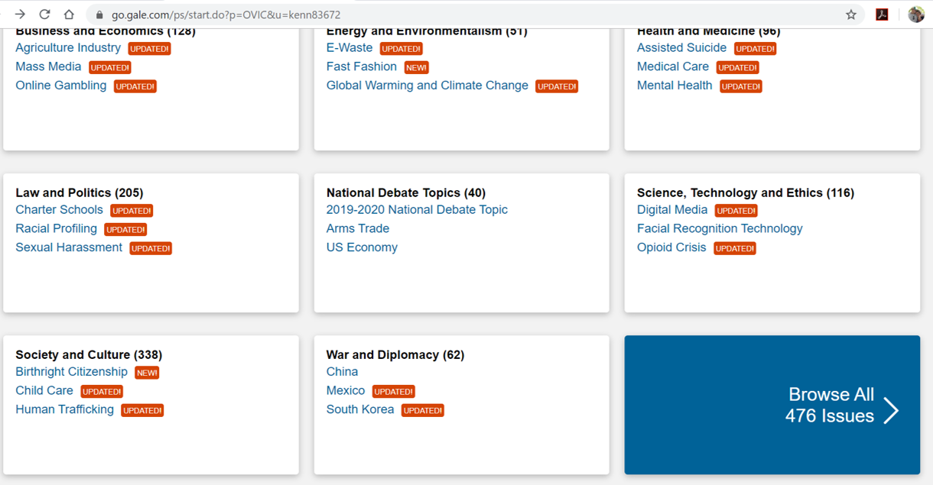

Step 4: Select SCHOOL START TIMES
You will initially see an overview of this topic but then below that, you will see clickable links to news articles, viewpoints, images, videos, websites, magazines

Step 5: Click on VIEWPOINTS and find the article “Summer Vacation is No Longer Necessary.” Open it.
Step 6: Cite the Article
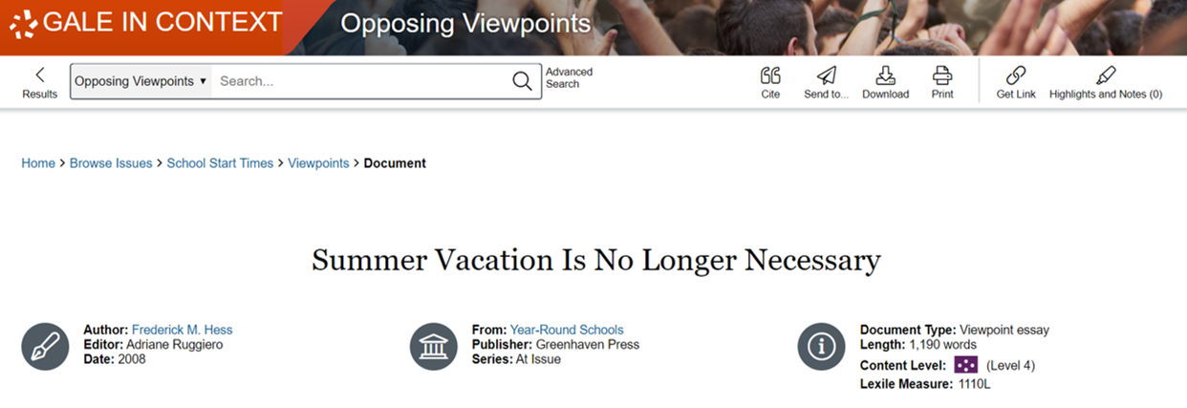
Find the button that says “Cite” and copy the citation for the article in the space below. Make sure that the citation is set to “MLA 8th Edition.” Then look at all of the component pieces to see how the citation was constructed.

Citation:

Author | Title of Article | Book Title | Publisher
Frederick M. Hess | “Summer Vacation Is No Longer Necessary” | Year-Round Schools | Greenhaven Press
Series | Editor | Publication Date | Database Name
At Issue | Adriane Ruggiero | 2008 | Gale in Context: Opposing Viewpoints
Access Date | Pages Used | URL | Original Publication

Step 7: Identify the Author’s Stance
Take a look at this sentence from the author’s opening paragraph and circle the words that help to establish the author’s critical tone and harsh diction.

But millions of others are loitering in parking lots and shopping malls, cruising iffy websites, and slouching toward academic disaster.

Note 5 reasons the author seems to think that summer vacation is a bad idea for American students:

1.

2.

3.

4.

5.

Step 8: Provide Your Own Commentary

What do you think about the author’s viewpoint? Use the space below to write a 4-6 sentence commentary in which you provide your own opinion on Frederick Hess’s perspective on summer vacation.
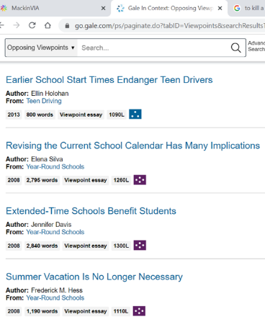
Step 9: Find a Different Viewpoint on the Same Issue
Now find the viewpoint article entitled “Revising the Current School Calendar Has Many Implications. You will find this article the same way you found the previous article.

Step 10: Cite the Article
Fill in the citation in the space below and then fill in the chart to see how the citation was formulated.
Citation:

Author | Title of Article | Book Title | Publisher
Series | Editor | Publication Date | Database Name
Access Date | Pages Used | URL | Original Publication
Step 11: Note Taking – take notes on each of the main sections of the viewpoint
The Changing School Calendar:

Not All Time in School Is Equal:

Extended Time and The Flow of Learning:

The Challenges of Extending School Time:

Strongest Opposition to Extended School:

No Certain Benefit in Extending Time in School:

Step 12: Provide Your Own Commentary
What do you think about the author’s viewpoint? Use the space below to write a 4-6 sentence commentary in which you provide your own opinion on Elena Silva’s perspective on changing the school calendar.
Step 13: Submit to Your Teacher
Save this document and share it with your teacher. You may either email it directly or share it through Office 365. Your teacher will email you a verification that the document was received and able to be opened for grading.

